WEEK 5 PROJECT REPORT

Payment Transaction Management System
Student Name: Maria Jency
Course: Bachelor of Computer Applications (BCA)
Project: E-Commerce Database Management
Week: 5
Database: ecommerceD__B
Technology: MySQL

1. Abstract
This project focuses on developing a Payment Transaction Management System for an e-commerce database. It stores customer payment details and tracks transaction statuses such as Success, Failed, and Pending. SQL queries are used to generate payment and revenue reports.

2. Aim
To manage customer payment transactions and analyze payment information using SQL.

3. Implementation
A new Payment table was created and connected to the existing Orders table through a foreign key. Primary key, unique, not null, and check constraints were applied to maintain data integrity.
Payment records were inserted using different payment methods. SQL SELECT and UPDATE statements were used to retrieve and manage transaction information. Aggregate functions such as COUNT, SUM, and AVG were used to analyze transactions and revenue.

4. Reports Generated
- Successful payment report.
- Failed transaction report.
- Pending transaction report.
- Payment mode analysis.
- Most preferred payment method.
- Total successful revenue.
- Revenue by payment method.
- Average transaction amount.
- Customer payment history.

5. Result and Output
The SQL queries were designed to manage payment transactions and generate payment-related business reports.
Screenshot 1: Payment table structure.
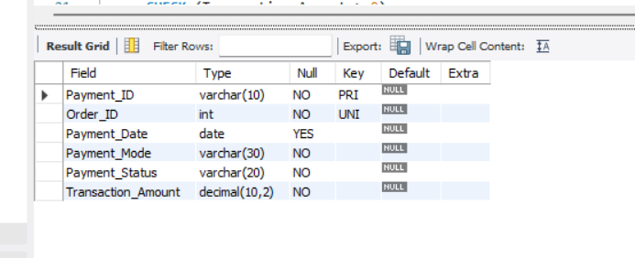
Screenshot 2: Inserted payment records.
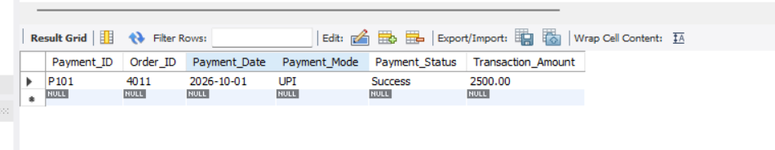
Screenshot 3: Successful and failed payment details.
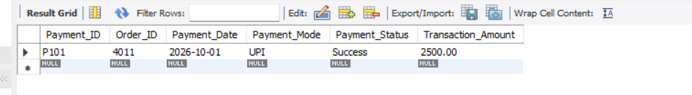

Screenshot 4: Payment mode analysis.
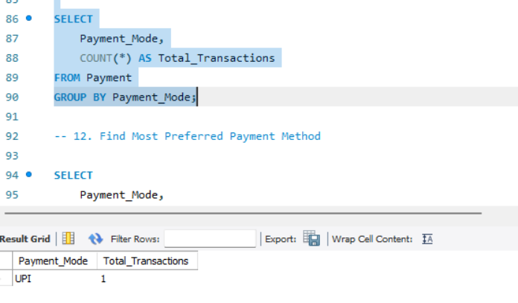
Screenshot 5: Total revenue report.
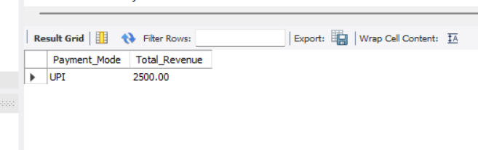
Screenshot 6: Customer payment history.
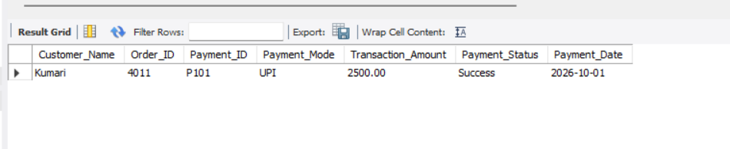

6. Conclusion
The Week 5 project demonstrates how SQL can be used to create and manage payment transactions in an e-commerce database. It provides practical experience with table relationships, constraints, transaction status updates, joins, and revenue analysis.

7. Future Enhancement
The system can be extended with payment gateway integration, automated transaction verification, refund management, and monthly revenue dashboards.

